COINS-Theodosius I Wife [**Aelia Flacilla**](https://stores.ebay.com/Authentic-Ancient-Greek-Roman-Coins/_i.html?_nkw=Aelia+Flacilla&submit=Search)**-379-388**

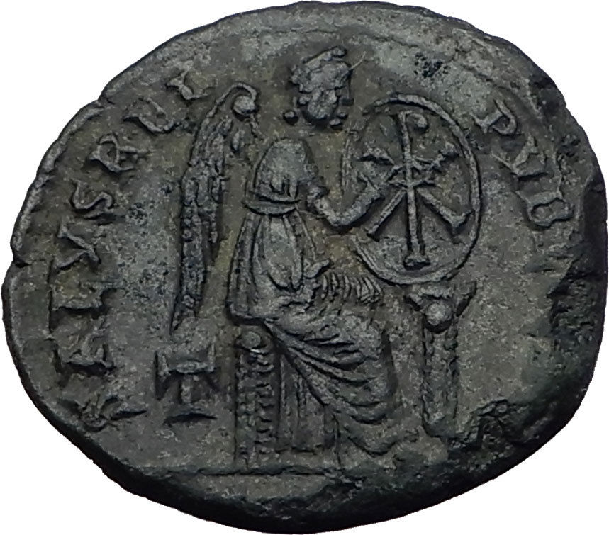 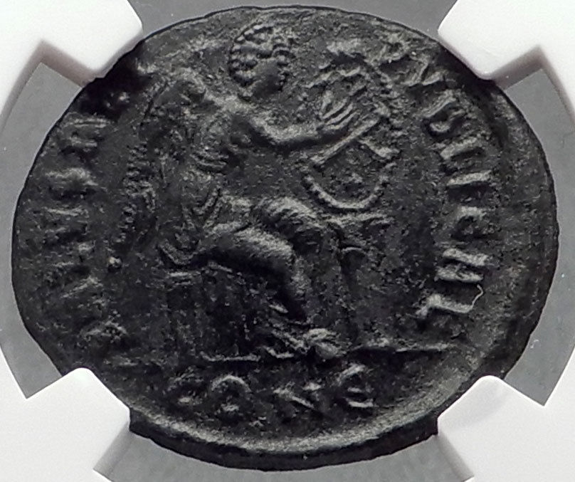

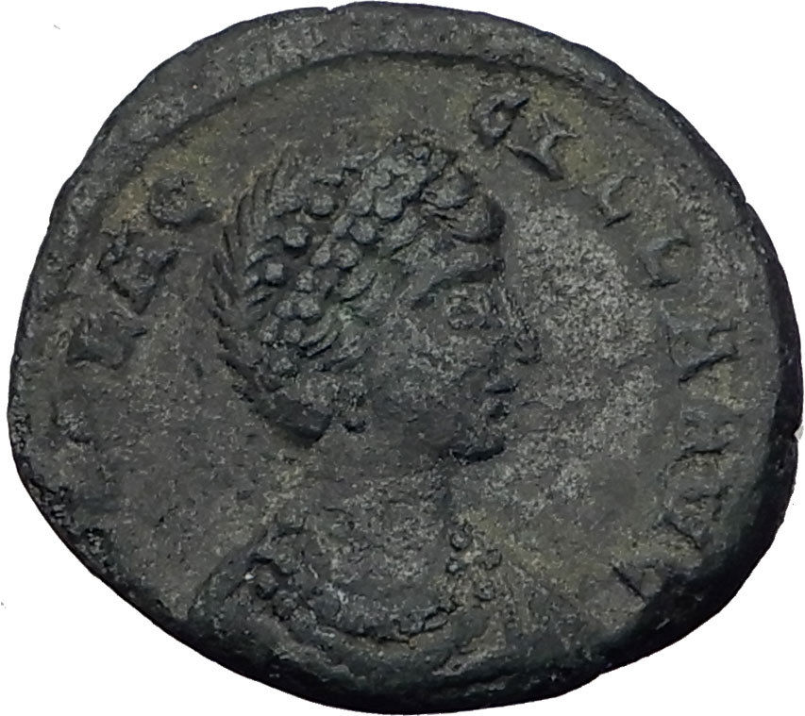 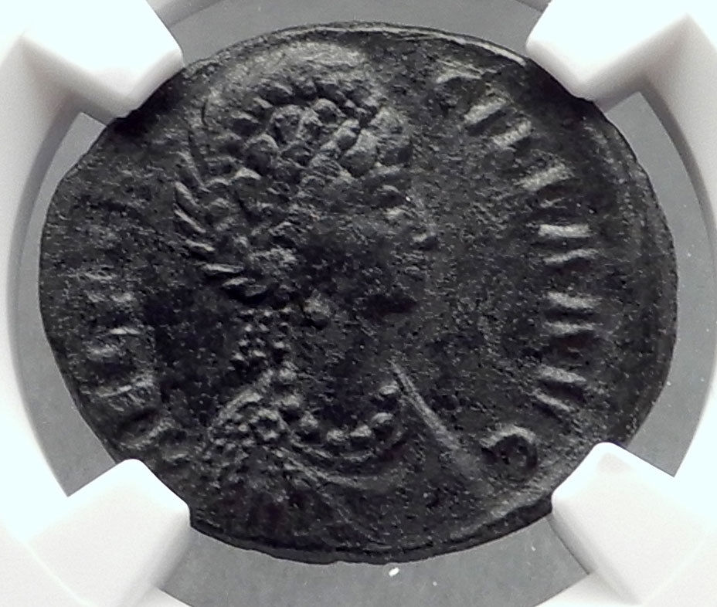

**Left:** [**Aelia Flacilla**](https://stores.ebay.com/Authentic-Ancient-Greek-Roman-Coins/_i.html?_nkw=Aelia+Flacilla&submit=Search)**-**[**Roman Empress**](https://stores.ebay.com/Authentic-Ancient-Greek-Roman-Coins/Roman-Coin-Collecting-Guide.html)**: 379-385 A.D. wife of**[**Theodosius I**](https://stores.ebay.com/Authentic-Ancient-Greek-Roman-Coins/_i.html?_nkw=Theodosius+I&submit=Search)Bronze AE2 21mm (4.53 grams) Struck circa 379-388 A.D.   
AEL FLACCILLA AVG - Diademed, draped bust bust right.   
SALVS REIPVBLICAE, Victory seated right on cuirass, holding shield on column with Chi-Rho inside.

**Right: Aelia Flacilla - Roman Empress: 379-385 A.D. wife of Theodosius I**Bronze AE2 24mm (4.51 grams) Constantinople mint: 379-388 A.D.   
Reference: RIC 81 (Constantinopolis)   
**Certification: NGC Ancients XF  4375823-036**  
AEL FLACCILLA AVG - Diademed, draped bust bust right.   
SALVS REIPVBLICAE Exe: CONЄ - Victory seated right on cuirass, holding shield on column   
with Chi-Rho inside.

 

[**Aelia Flacilla**](https://stores.ebay.com/Authentic-Ancient-Greek-Roman-Coins/_i.html?_nkw=Aelia+Flacilla&submit=Search)**-**[**Roman Empress**](https://stores.ebay.com/Authentic-Ancient-Greek-Roman-Coins/Roman-Coin-Collecting-Guide.html)**: 379-385 A.D. wife of**[**Theodosius I**](https://stores.ebay.com/Authentic-Ancient-Greek-Roman-Coins/_i.html?_nkw=Theodosius+I&submit=Search)Bronze AE2 21mm (4.53 grams) Struck circa 379-388 A.D.   
AEL FLACCILLA AVG - Diademed, draped bust bust right.   
SALVS REIPVBLICAE, Victory seated right on cuirass, holding shield on column with Chi-Rho inside.

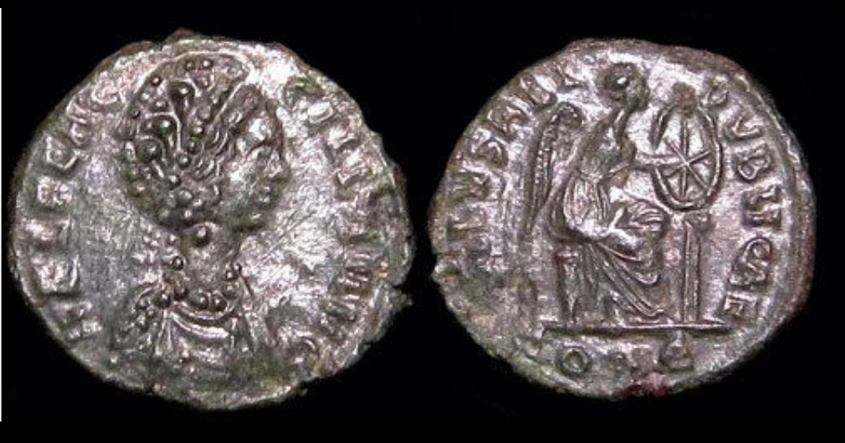

**AELIA FLACILLA ,**

**wife of Theodosius I , c. 379-395 AD, AE4+++**

**PERIODNAME: Roman Imperial**

**TITLE: AELIA FLACILLA , wife of Theodosius I , c. 379-395 AD**

**DATE:  circa after 383-384 AD**

**MINT: Siscia**

**DENOMINATION: AE4**

**MATERIAL: AE**

**OBVERSE: AEL FLAC-CILLA AVG Diademed, draped bust r., wearing necklace**

**REVERSE: SALVS REI – PVBLICAE , Victory seated right on cuirass, holding shield on column with Chi-Rho inside , CONЄ in exergue.**

**MINTMARKS: CONЄ**

**CONDITION:  EF**

**REFERENCE: RIC IX RIC 55\ (Scarce), page 226**

**WEIGHT: 0.8 g.**

**DIAMETER: 12 mm.**

**TYPE: Scarce**

**NOTES: Attractive quality for such a small coin, dark glossy patina, from an old collection**

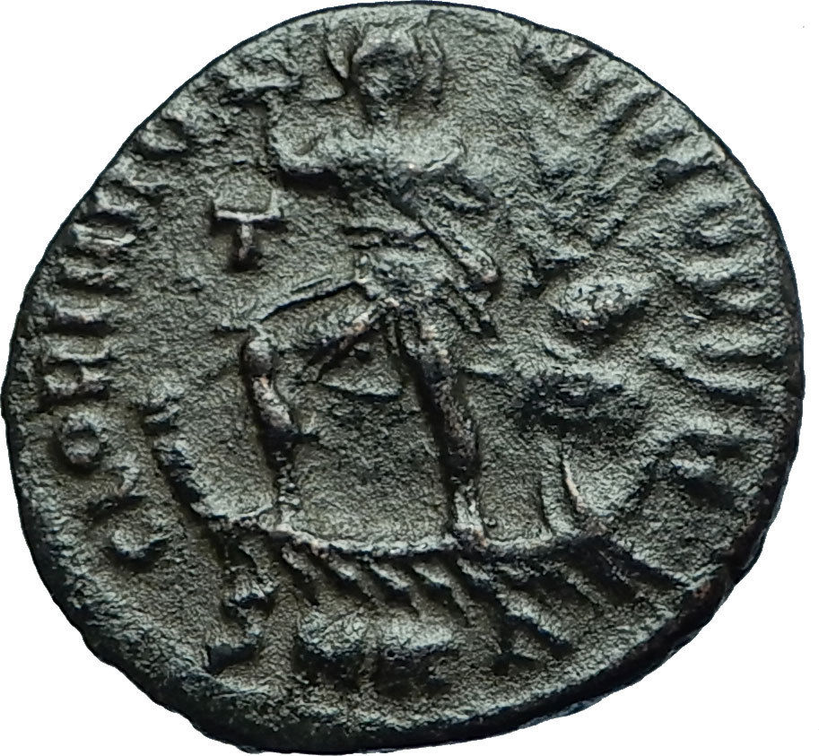 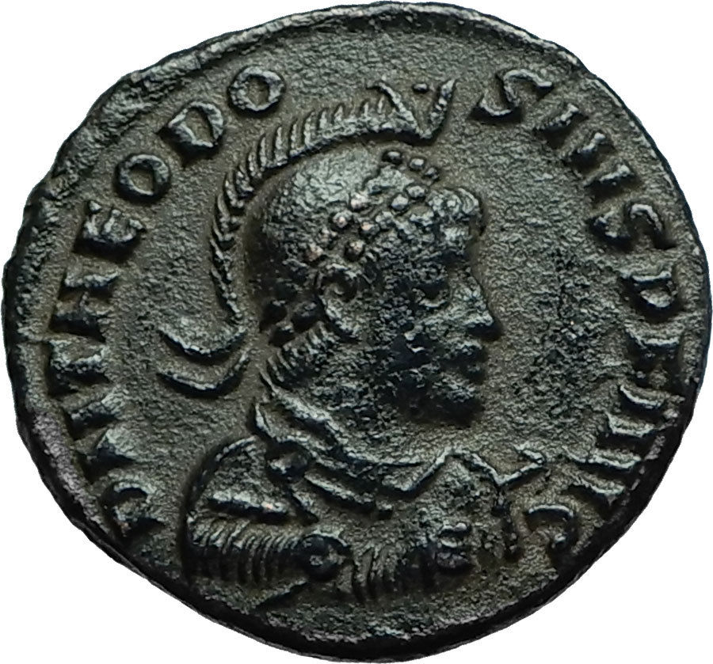

[**Theodosius I 'the Great'**](https://stores.ebay.com/Authentic-Ancient-Greek-Roman-Coins/_i.html?_nkw=Theodosius+I&submit=Search)**-**[**Roman Emperor**](https://stores.ebay.com/Authentic-Ancient-Greek-Roman-Coins/Roman-Coin-Collecting-Guide.html)**: 379-395 A.D.**Bronze AE2 22mm (4.90 grams) Cyzicus mint, struck circa 383-388 A.D.  
Reference: RIC IX 23  
D N THEODOSIVS P F AVG, Pearl-diademed, helmeted, draped and cuirassed bust right, shield in left hand, spear pointing forward in right hand  
GLORIA ROMANORVM / T/SMKΔ, emperor standing facing in galley sailing left piloted by Victory, head right, right hand raised.

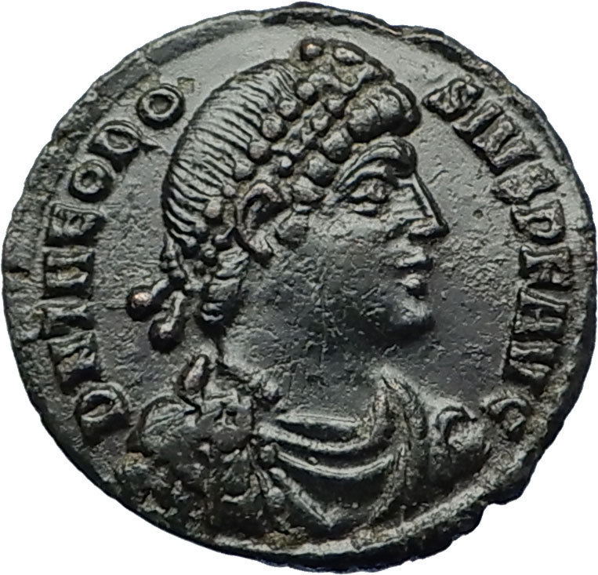 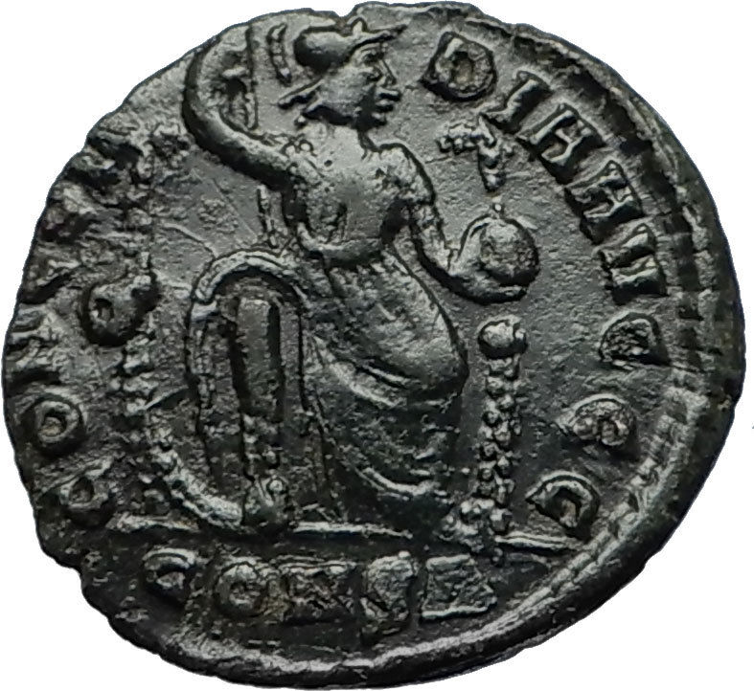

[**Theodosius I 'the Great'**](https://stores.ebay.com/Authentic-Ancient-Greek-Roman-Coins/_i.html?_nkw=Theodosius+I&submit=Search)**-**[**Roman Emperor**](https://stores.ebay.com/Authentic-Ancient-Greek-Roman-Coins/Roman-Coin-Collecting-Guide.html)**: 379-395 A.D.**Bronze AE3 17mm (2.18 grams) Constantinople mint, struck 378-383 A.D.  
Reference: RIC 57a  
D N THEODOSIVS P F AVG, Pearl-diademed, draped and cuirassed bust right.  
CONCORDIA AVG G G / O/CONS - Constantinopolis seated, facing, holding spear and globe.

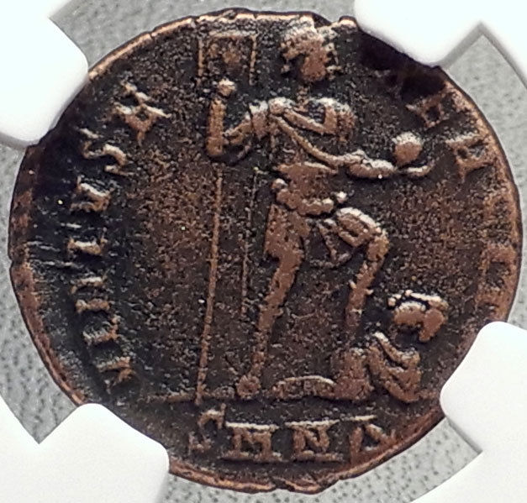 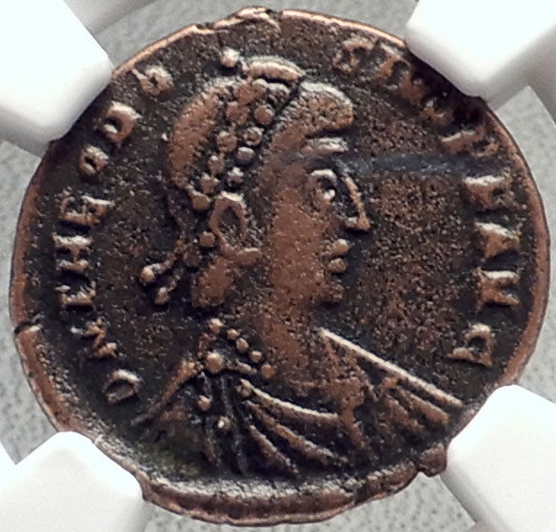

[**Theodosius I 'the Great'**](https://stores.ebay.com/Authentic-Ancient-Greek-Roman-Coins/_i.html?_nkw=Theodosius+I&submit=Search)**-**[**Roman Emperor**](https://stores.ebay.com/Authentic-Ancient-Greek-Roman-Coins/Roman-Coin-Collecting-Guide.html)**: 379-395 A.D.**Bronze AE2 22mm (5.02 grams) Nicomedia mint, struck circa 383-388 A.D.  
Reference: RIC 44b; LRBC 2394  
**Certification:**[**NGC Ancients**](https://stores.ebay.com/Authentic-Ancient-Greek-Roman-Coins/_i.html?_nkw=ngc&submit=Search)**VF  4680703-005**  
D N THEODOSIVS P FAVG, Pearl-diademed, draped bust right.  
VIRTVS EXERCITI / SMNΔ, Theodosius I standing right, stepping on captive, holding labarum and globe.

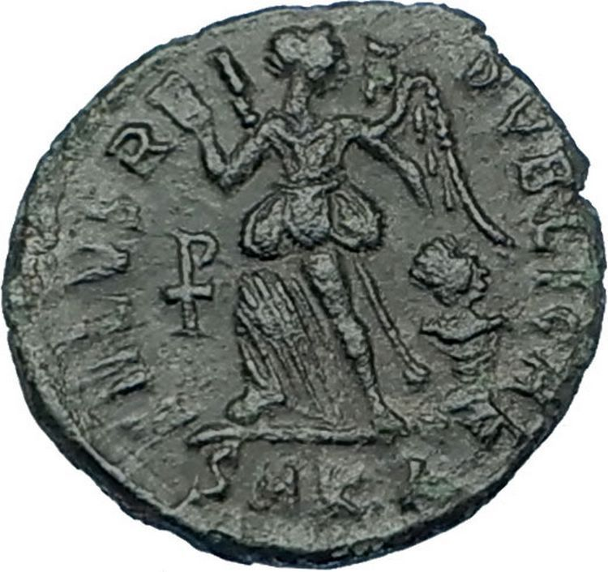 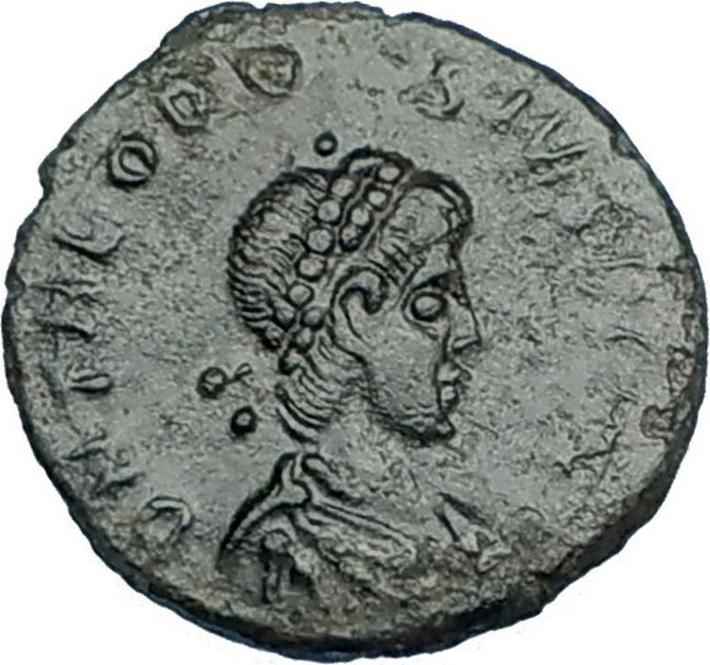

[**Theodosius I 'the Great'**](https://stores.ebay.com/Authentic-Ancient-Greek-Roman-Coins/_i.html?_nkw=Theodosius+I&submit=Search)**-**[**Roman Emperor**](https://stores.ebay.com/Authentic-Ancient-Greek-Roman-Coins/Roman-Coin-Collecting-Guide.html)**: 379-395 A.D.**Bronze AE4 12mm (1.13 grams) Cyzicus mint 388-392 A.D.  
Reference: RIC 26b/30b (Cyzicus), LRBC 2569/2577  
D N THEODOSIVS P F AVG, Diademed, draped and cuirassed bust right.  
SALVS REIPVBLICAE / Staurogram/SMKA, Victory advancing left, holding trophy and dragging captive.

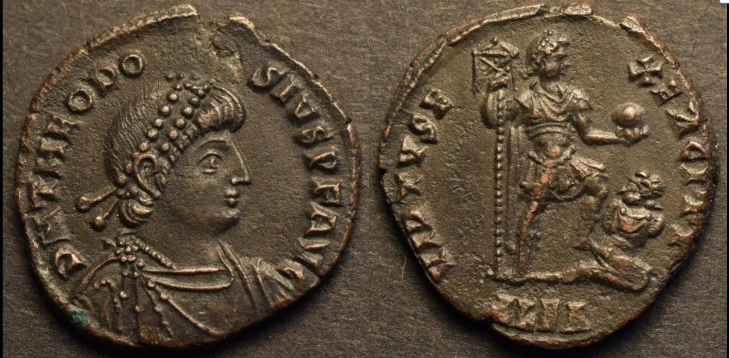

*Theodosius I AE22*

Obverse : D N THEODOSIVS P F AVG - Diademed, draped and cuirassed bust right.  
  
Reverse : VIRTVS EXERCITI - Emperor standing right, holding Labarum signum and globe, his left foot on captive seated right; ALEA in exergue (Alexandria mint).  
  
Date : 383-388 CE  
  
Diameter : 21.87 mm  
  
Weight : 5.11 g  
  
References : RIC 18b   
  
Notes : Ex CNG 388 Lot 532